Static and dynamic addressing

Static IPv4 addressing assignment

IPv4 addresses can be assigned either statically or dynamically

**Static assignment, the network administrator must MANUALLY configure the network information for host**

At minimum that is:

IP ADDRESS identifies the host on the network

SUNET MASK used to identify the network on which the host is

DEFAULT GATEWAY networking device that the host uses to access the internet or another remote network

Static addresses have some advantages

For instance: useful for printers, servers and other networiking devices that need to be accessible to clients on the network

It can provide increased control of network resources, but it can be time consuming to enterthe information on each host

Dynamic IPv4 address assignment

Rather than having administrator assign IPv4 addresses for each workstation, it is easier to have IPv4 addresses assigned automatically. This is done using a protocol known as Dynamic host configuration protocol (DHCP)

DHCP automatically assigns addressing information such as IPv4 address, subnet mask, default gateway, and other configuration information

Its generally the preferred method of assigning IPv4 addresses to hosts on large networks because it **reduces the burden on network support staff and eliminates entry errors**

Another benefit is that an address in not permanently assigned to a host but only leased for a period of time. **If host is powered down or taken off the network, the address is returned to the pool for reuse**

DHCP servers

If you enter an airport or coffee shot with hotspot, DHCP makes it possible for you to access the internet

As you enter the area your DHCP client contacts the local DHCP server via a wireless connection. The DHCP server assigns an IPv4 address to your device

**Medium to large networks** the DHCP server is usually a local **dedicated PC-based server**

**Home networks** the DHCP server may be **located at the ISP** and host on the hone network receives its IPv4 configuration directly from ISP

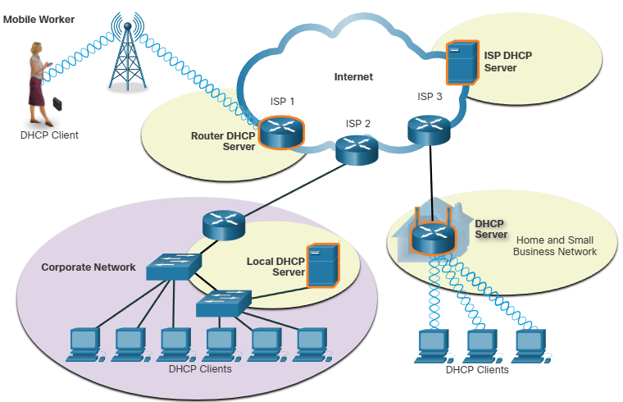

Home networks and small businesses use wireless routers and modem

In this case router is both DHCP client and a server

Router acts as a client to receive its IPv4 config from the ISP and then acts as a DHCP server for internal hosts on the local network